**ICA**

**BIG DATA AND BUSINESS INTELLIGENCE**

**NAME: [PUT NAME HERE]**

**STUDENT ID: [PUT STUDENT ID HERE]**

**Table of Contents**

**Business Intelligence Design**

**1 Dataset Description and Business Intelligence Question**

1.1 Data Source Description

1.2 Why Chose this Dataset?

1.3 Dataset Description

1.4 Loading Data into Power BI Environment

1.5 Business Intelligence Questions

**2 Data pre-processing and Data Cleansing**

**3 BI Data Modelling**

3.1 Creating the Calendar Table

**Section 2: Business Report**

1. Introduction

2. Key Findings

3. Conclusion

4. Recommendations

**1.1 Data Source Description**

For this assignment, the dataset used is the Adventure Works Dataset. The Adventure Works Database is a Microsoft product for an online transaction processing (OLTP) database. It supports a fictitious, multinational manufacturing company called Adventure Works Cycles (Fontechio, 2013). The database is made available for use as examples in SQL Server documentation and books. The database is made available on Kaggle for public use. The link to the CSV version of the dataset is provided below:

<https://www.kaggle.com/ukveteran/adventureworks>

The dataset consists of sales made available by Adventure Works Cycle within the periods covered by the dataset used.

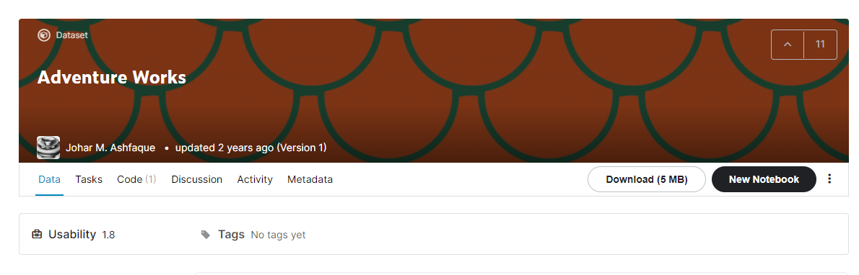

**Fig 1: Screenshot showing the data source**

**1.2 Why Chose This Dataset?**

The Adventure Works Dataset is chosen because it has the necessary attributes that makes it suitable for answering important Business Intelligence questions. It enables analysts solve problems which managers of business encounter daily in their business. This will be made possible by using the Business Intelligence software program, Power BI. Power BI is easy to get started with, making it easier for an analyst to handle, and begin working with the data presented in no time. The Adventure Works dataset allows creating data modelling easily, enabling easy creation of relationship among the tables.

**1.3 Dataset Description**

This dataset consists of 6 tables, 5 of which were used to achieve the objectives of this project. Any other table(s) needed will be created in Power BI. The tables imported into Power BI are described below:

|  |  |  |  |  |  |  |  |  |
| --- | --- | --- | --- | --- | --- | --- | --- | --- |
| **Table Name** | | **Number of Columns** | | | | **Number of Rows** | **Column Name** | **Column Description** |
| Adventure_Works_Sales | | 26 | | | | 60,399 | ProductKey | Product ID |
| OrderDateKey | ID of the order date |
| DueDateKey | ID of the due date |
| ShipDateKey | Ship date ID |
| CustomerKey | ID of the customers |
| PromotionKey | Promotion ID |
| CurrencyKey | ID of the currency |
| SalesTerritoryKey | ID of the sales territory |
| SalesOrderNumber | Unique ID for sales order |
| SalesOrderLineNumber | ID for sales order line |
| RevisionNumber | ID of revision number |
| OrderQuantity | Quantity of orders made |
| UnitPrice | The unit price of each item sold |
| ExtendedAmount | The extended amount of each item sold. |
| UnitPriceDiscountPct | Percentage of unit price discount |
| Discountamount | Amount of discount |
| ProductStandardCost | Standard cost of the product |
| TotalProductCost | Total cost of the  product |
| SalesAmount | The amount of sales |
| TaxAmount | The amount of tax |
| Freight | The cost of freight |
| CarrierTrackingNumber | Number of carrier tracking |
|  | |  | | | |  | CustomerPONumber | Purchase order number of customers |
| OrderDate | Date in which the item was ordered |
| DueDate | Date in which the item was due for delivery |
| ShipDate | Date in which the item is to be shipped |
| AdventureWorks_Customers | | 30 | | | | 18,484 | CustomerKey | Unique ID of customers |
| GeographyKey | Unique ID of the geography |
| CustomerAlternateKey | Unique alternate ID for customers |
| Title | Title of the customers |
| FirstName | The first name of the customers |
| MiddleName | The middle name of the customers |
| LastName | The last name of the customer |
| NameStyle | The style of the customers’ names |
| BirthDate | Date of birth of the customers |
| MaritalStatus | The marital status of the customers |
| Suffix | The suffix of the customers’ names |
| Gender | The gender of the customers |
| EmailAddress | The email address of the customers |
|  |  | | | |  | | YearlyIncome | The yearly income of the customers |
| TotalChildren | The total number of children of the customers |
| NumberChildrenAtHome | The total number of children at home |
| EnglishEducation | The certificate held in English education |
| SpanishEducation | The certificate held in Spanish education |
| FrenchEducation | The certificate held in French education |
| EnglishOccupation | The English occupation of a customer |
| SpanishOccupation | The Spanish occupation of a customer |
| FrenchOccupation | The French occupation of a customer |
| HouseOwnerFlag | The flag of the houseowner |
| NumberCarsOwned | The number of cars owned |
| AddressLine1 | The first address line |
| AddressLine2 | The second address line |
| Phone | The phone number of customers |
| DateFirstPurchase | The date of first purchase |
| CommuteDistance | Distance of commuting |
| Test | Test done for the customers |
| AdventureWorks_Product | 36 | | 771 | | | | ProductKey | Unique ID of the product |
| ProductAlternateKey | Alternate unique ID of the product |
| ProductSubcategoryKey | ID of product subcategory |
| WeightUnitMeasureCode | Unit measure code of weight |
| SizeUnitMeasureCode | Unit measure code of size |
|  |  | | |  | | | EnglishProductName | English name of product |
| SpanishProductName | Spanish name of product |
| FrenchProductName | French name of product |
| StandardCost | Standard cost |
|  | |  | | | |  | FinishedGoodsFlag | Flag of finished goods |
| Color | Color |
| SafetyStockLevel | The level of safety stock |
| ReorderPoint | Point at which a reorder is made |
| ListPrice | List of price |
| Size | Size of product |
| SizeRange | Range of size |
| Weight | Weight of product |
| DaysToManufacture | Days to manufacture the products |
| ProductLine | The product line |
| DealerPrice | The dealer price |
| Class | Class of the product |
| Style | Style of the product |
| ModelName | Name of the model |
| LargePhoto | Large photo for the product |
| EnglishDescription | Description of product in English |
|  | FrenchDescription | Description of product in French |
| ChineseDescription | Description of product in Chinese |
| ArabicDescription | Description of product in Arabic |
| HebrewDescription | Description of product in Hebrew |
| ThaiDescription | Description of product in Thai |
| GermanDescription | Description of product in German |
| JapaneseDescription | Description of product in Japanes |
| TurkishDescription | Description of product in Turkish |
| StartDate | Start date of product |
| EndDate | End date of product |
| Status | Status of product |
| AdventureWorks_Product | | 5 | | | | 4 | ProductCategoryKey | Unique ID of product category |
| ProductCategoryAlternateKey | Unique alternate key of product category |
| EnglishProductCategoryName | English Name of product category |
| SpanishProductCategoryName | Spanish name of product category |
| FrenchProductCategoryName | French name of product category |
| AdventureWorks_ProductSubCategory | | 6 | | | | 37 | ProductSubcategoryKey | Unique ID of product subcategory |
| ProductSubcategoryAlternateKey | Alternate unique Id of product subactegory |
| EnglishProductSubcategoryName | English name of product subcategory |
| SpanishProductSubcategoryName | Spanish name of product subcategory |
|  | |  | | | |  | FrenchProductSubcategoryName | French name of product subcategory |
| ProductCategoryKey | ID of product category |
| AdventureWorks_SalesTerritory | | 5 | | | | 10 | SalesTerritoryKey | Unique ID of sales territory |
| SalesTerritoryAlternateKey | Unique alternate ID of sales territory |
| SalesTerritoryRegion | Region of sales territory |
| SalesTerritoryCountry | Country of sales territory |
| SalesTerritoryGroup | The group of sales territory |

**1.4** **Loading Data into Power BI Environment**

For any Business Intelligence tasks to be done in Power Bi, the first important step is to load the data into Power BI. Having done that, the data analysis can begin in earnest, answering important questions with the available dataset. Microsoft Power BI is a Business Intelligence software capable of being used for wide array of Business Intelligence problems. It can work with data that come from various sources such as MS Excel files, databases like Oracle, MySQL, MS Access, web API, TEXT/CSV files, OData Feed, GitHub, Salesforce, Google Analytics and so on.

When Power BI is opened, a dialog box pops up, showing Get data option and any ongoing or existing projects as shown in the figure below:

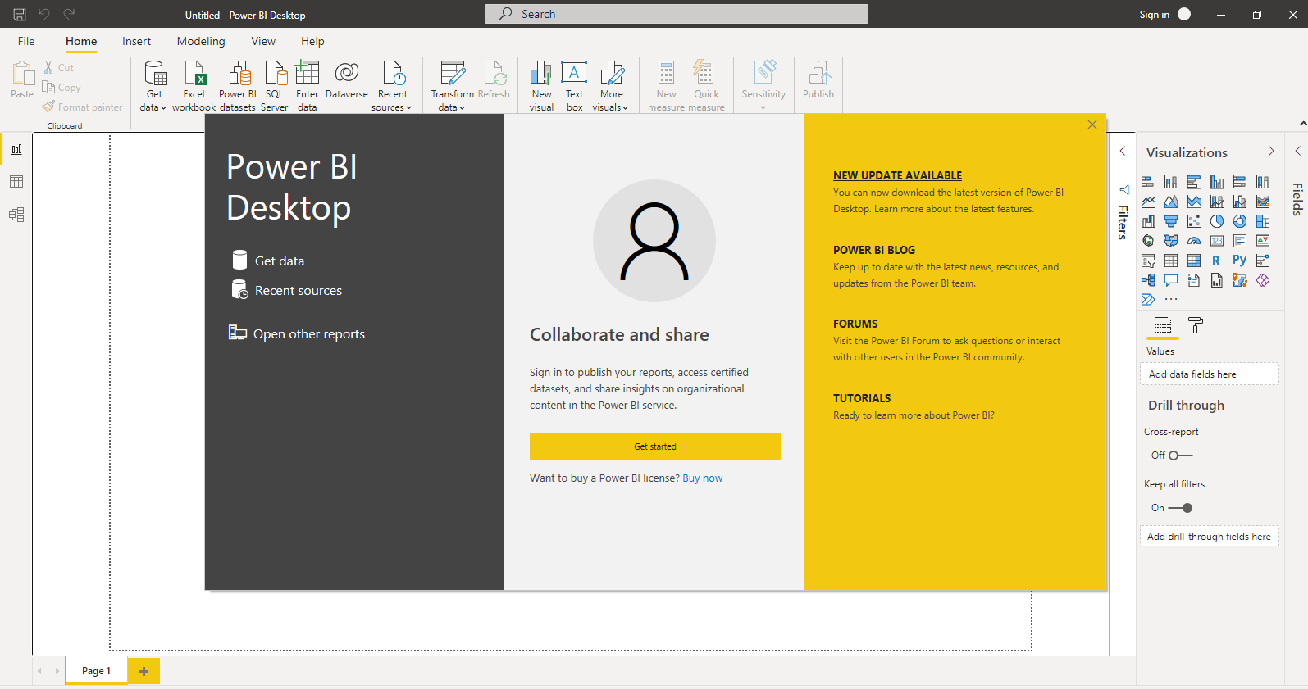

**Fig 2: Power BI start up screen**

To begin the analysis necessary for this project, it is necessary to load data in the Adventure Works database into Power BI environment. The CSV files containing the data to be used for this project are loaded into Power BI through the Get Data option. The screenshot below shows the Get Data dialog.

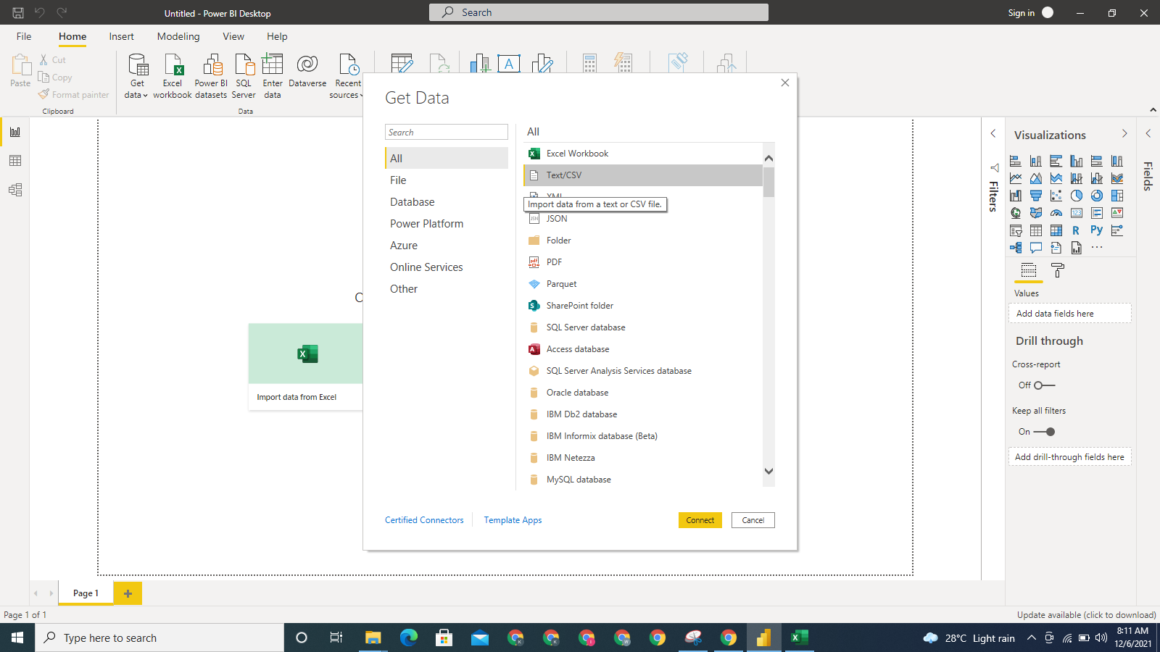

**Figure 3: Screenshot showing the Get Data dialog box**

Each table to be used for this project is stored in a CSV file, and they will be loaded in turn into Power BI. A screen shot of one the tables is presented below:

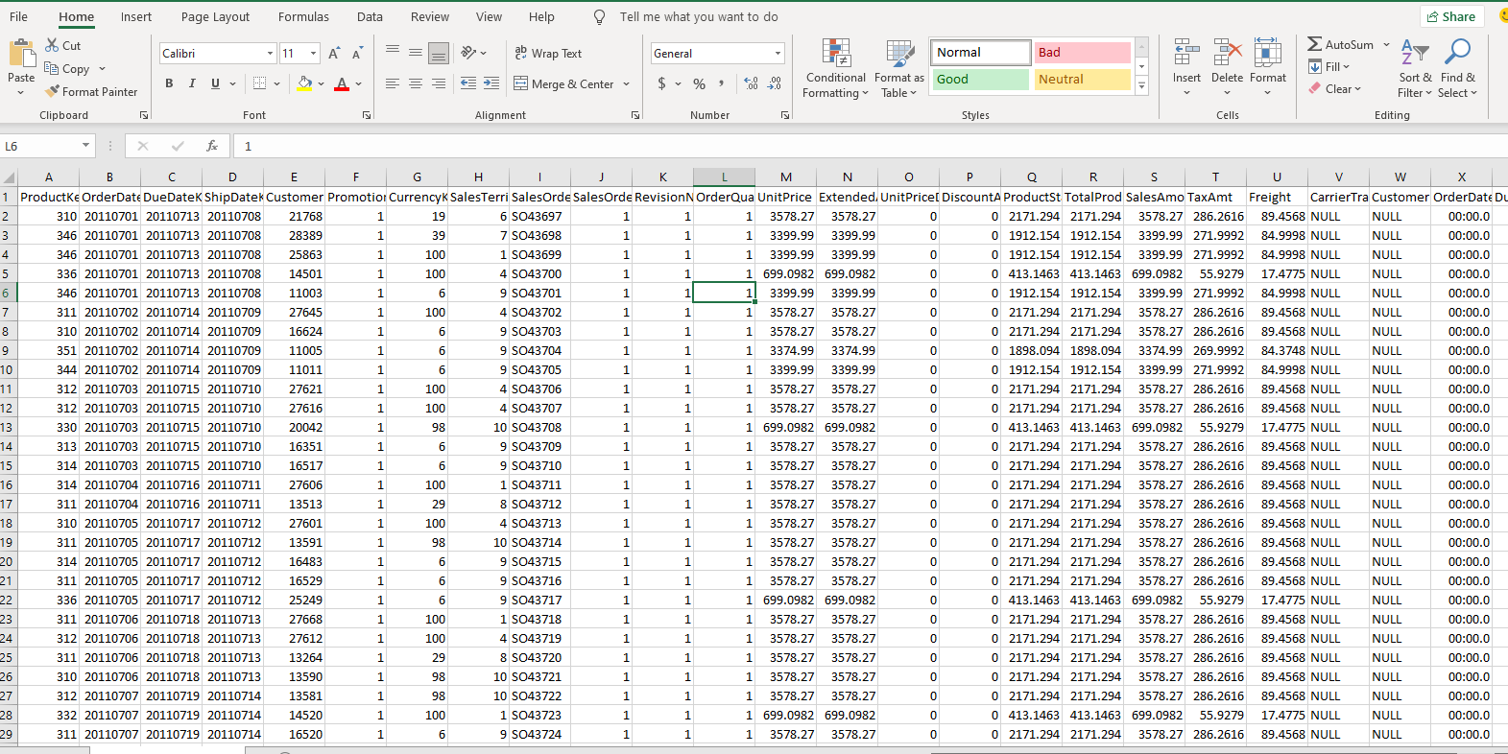

**Fig 4: Screenshot showing the data in a CSV file**

The data was then loaded into Power BI by clicking on the Load option shown below. The screenshot below shows the data in the sales table being loaded into Power BI:

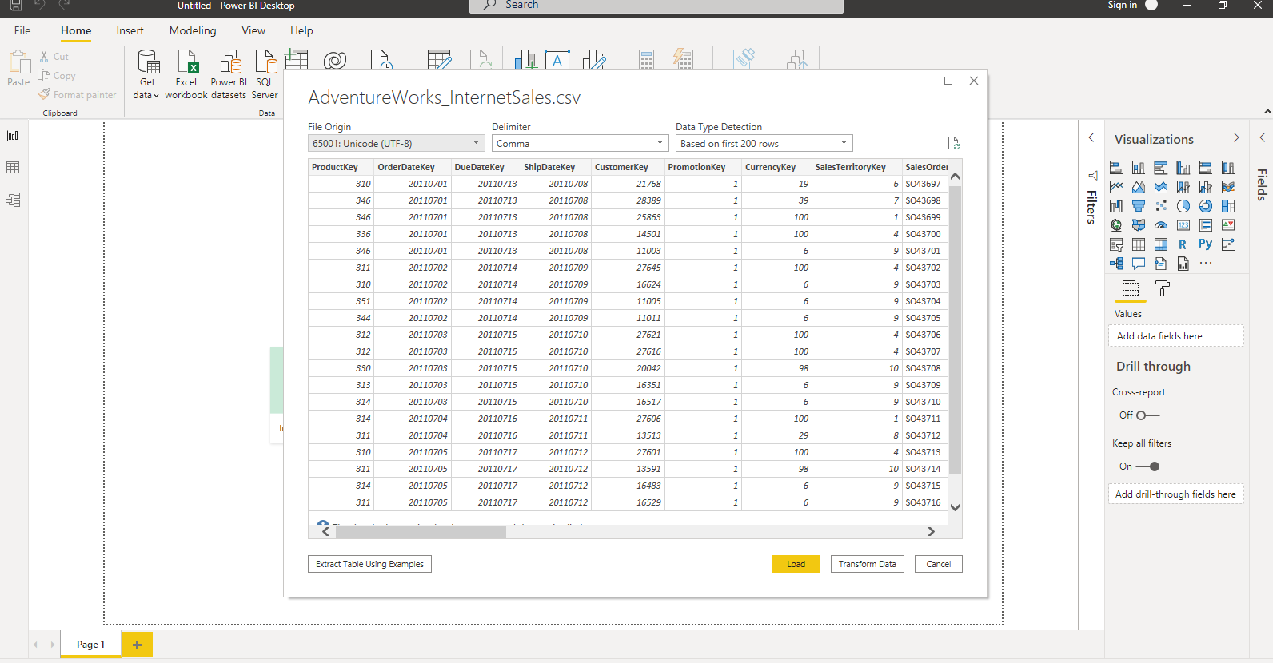

**Fig 5: Loading the AdventureWorks_Sales.csv file into Power BI**

Other CSV files containing the data needed for this project will be loaded into Power BI in a similar way as the above. The table names of the other data in CSV files are AdventureWorks_Customers, AdventureWorks_Products, AdventureWorks_Product, AdventureWorks_ProductCategory, AdventureWorks_ProductSubcategory, and AdventureWorks_SalesTerritory.

**1.5 Business Intelligence Questions**

The Business Intelligence questions this report will answer include:

* What is the total sales year to date?
* What is the revenue coming from each territory?
* Which gender makes most purchases?
* What is the month on month profit growth for the 2014 financial year?
* What is the year on year growth of the revenue?
* What is the average amount spent on freight?
* What category of educated people produces the most revenue?
* What is the average cost of production over the years?
* What is the minimum, maximum and average safety stock level?

**2 Data pre-processing and Data Cleansing**

Having load the data into Power BI, the next step is to perform essential pre-processing of the data and also cleansing the data to get it ready for answering business intelligence questions. Some of the data pre-processing and cleansing to be done include changing table names, promoting the column headers, dropping unwanted columns, removing unwanted rows, changing data types, creating a calendar table. All these are made easy with the power BI Query Editor. To begin the data processing, the Transform Data option was selected from the Home tab of the Power BI screen to open the Query Editor.

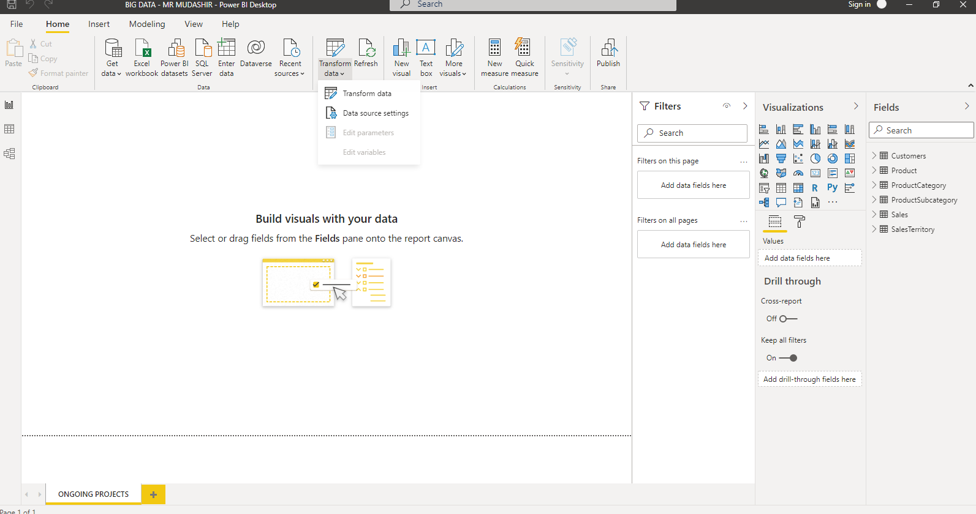

**Figure 6: Screenshot showing the Transform Data being selected**

Using the AdventureWorks_Sales table for instance, the table name was changed to Sales by double-clicking the query name while in the Query Editor under Queries.

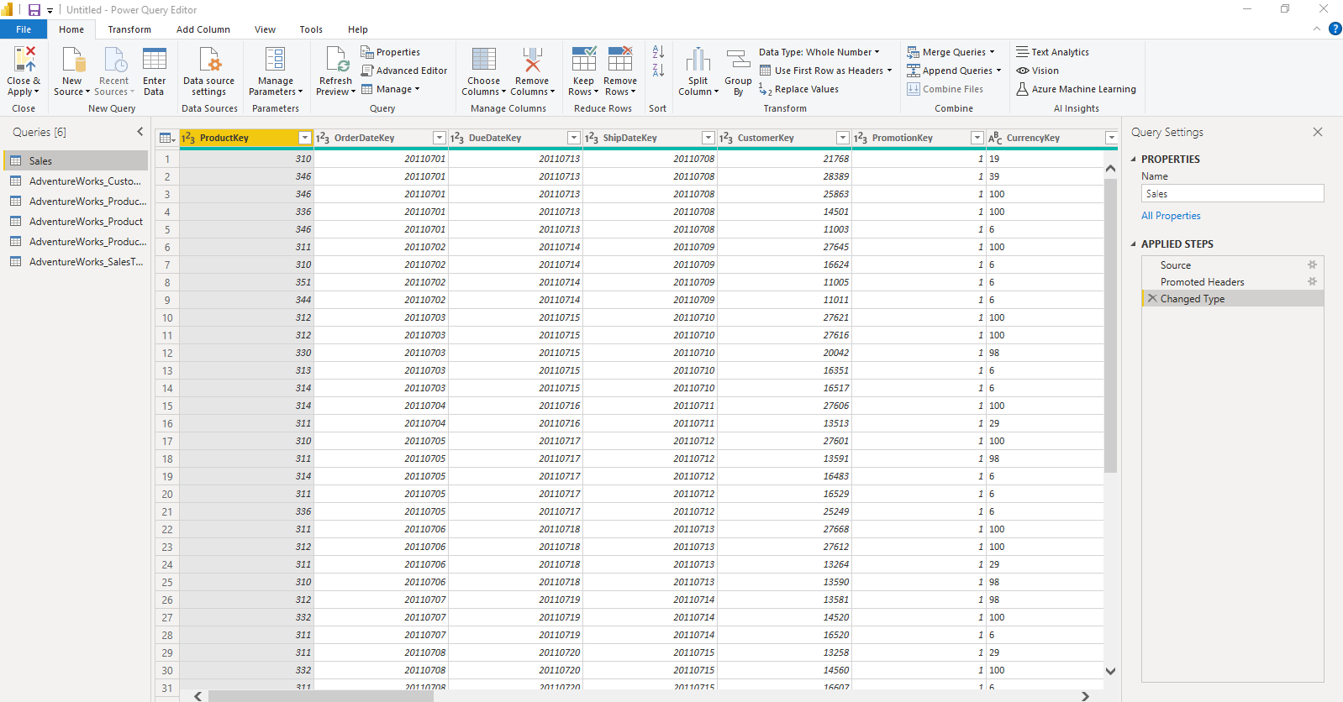

**Figure 7: Screenshot showing the change of a table name to a new name**

Similarly, other table names were changed to more suitable names. AdventureWorks_Customers was changed to Customers, AdventureWorks_Product changed to Product, AdventureWorks_ProductCategory changed to ProductCategory, AdventureWorks_ProductSubcategory changed to ProductSubcategory and AdventureWorks_SalesTerritory changed to SalesTerritory.

Next, the unneeded column names were removed from the affected tables. This was also done in the Query Editor by clicking on the Remove Columns option in the **Home** tab. The table used here as example is the Customers table. The columns removed from the Customers table include Title, NameStyle, Suffix, EmailAddress, AddressLine1, AddressLine2, CommuteDistance, and test. After the columns were removed, a step named “Removed Columns” was added to the **APPLIED STEPS** under the **Query Settings** on the right side of the screen. This is shown in the screenshot below:

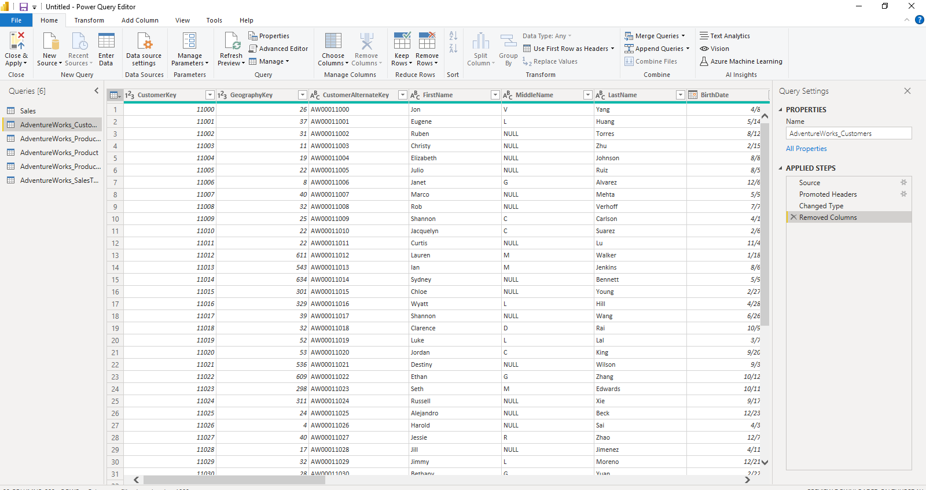

**Figure 8: Screenshot showing in the Applied Steps that the unneeded columns have been removed**

Unneeded columns were removed from other tables also.

The columns having Date/Time were split into separate columns so that there can be columns having only Date type, after this the columns having Time data type were removed; the columns having Date data type were then renamed properly. Figures 9, 10 and 11 below show the process followed in separating, and renaming the columns containing Date type.

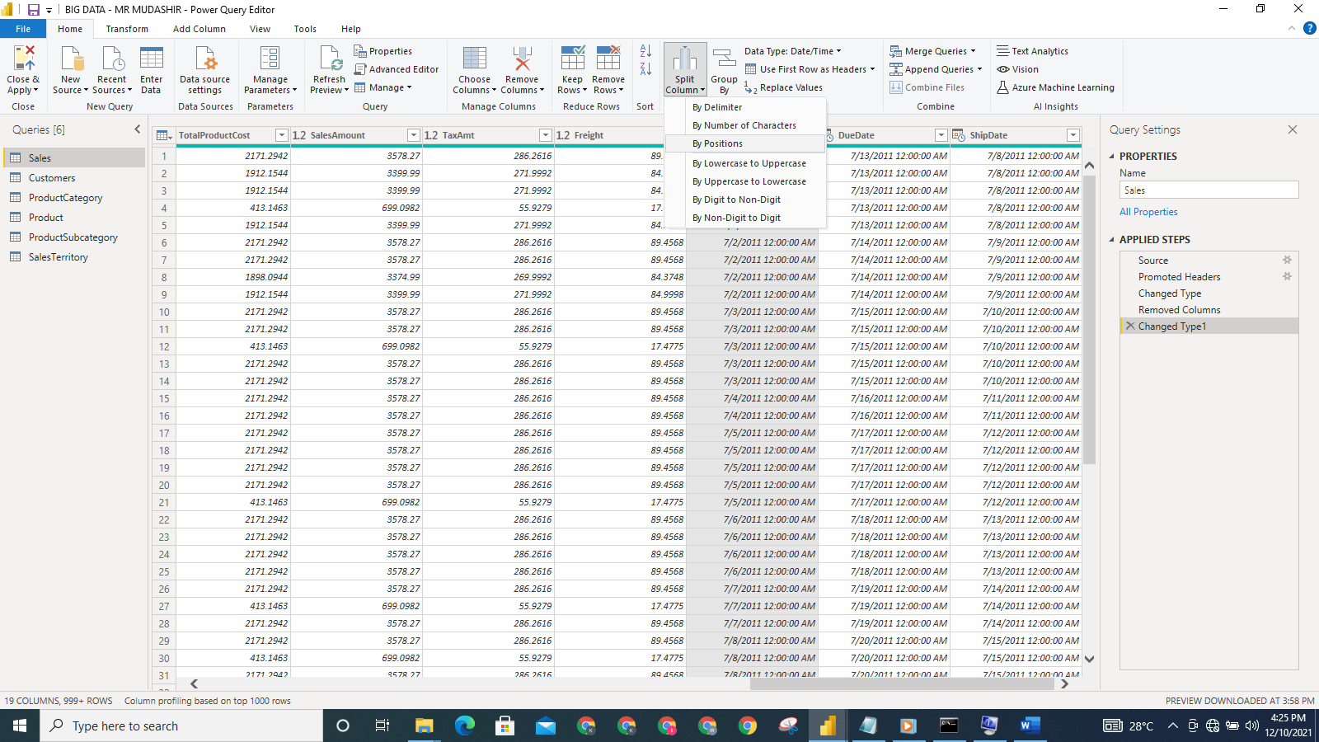

**Figure 9: Screenshot showing the Split Columns By Positions being selected**

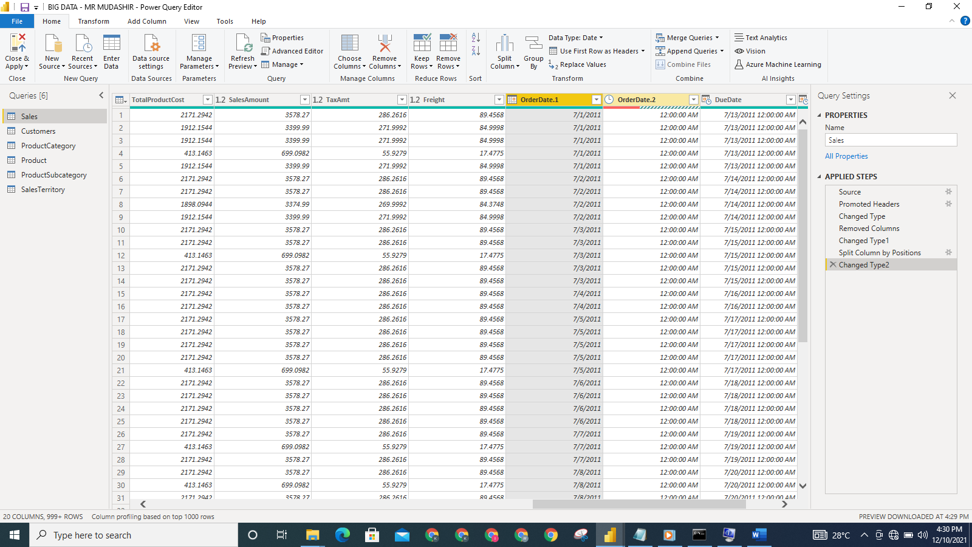

**Figure 10: Screenshot showing the two new columns created after the OrderDate column in the Sales data is split**

The step: **Split Columns by Position** is added to the **APPLIED STEPS**. Because the data type is changed automatically also, the step: **Changed Type2** was added to the **APPLIED STEPS**. OrderDate.1 column is changed to OrderDate and OrderDate.2 was removed as shown in the screenshot below:

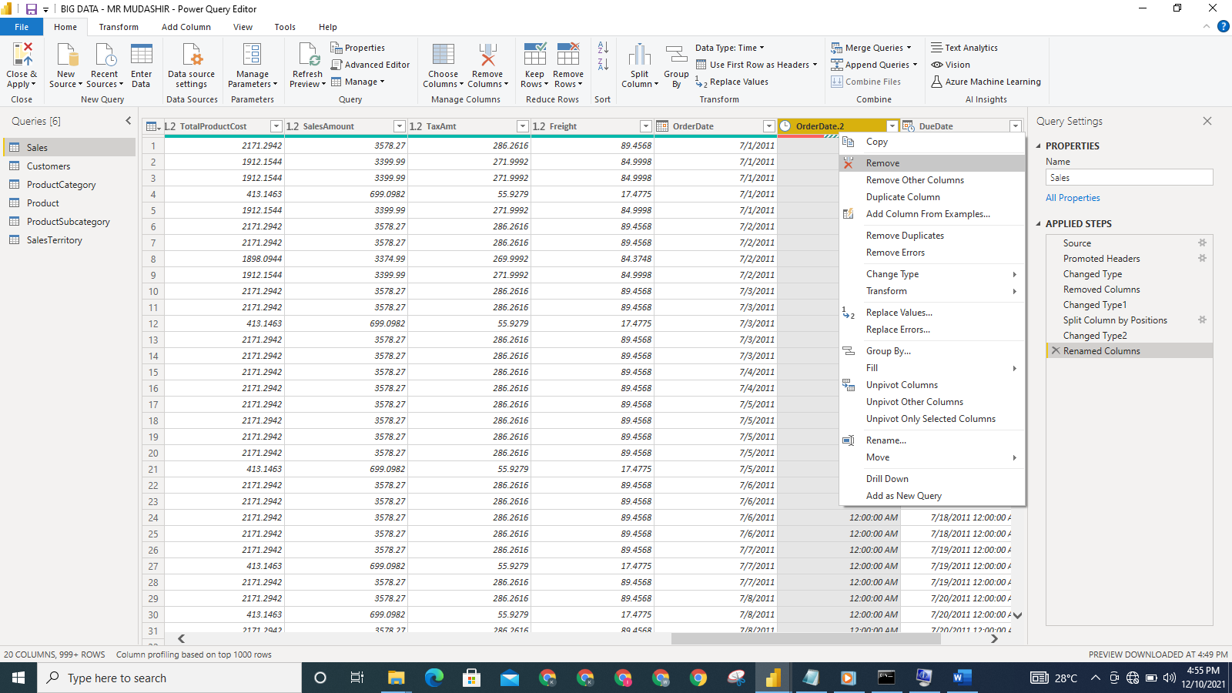

**Figure 11: Screenshot showing OrderDate.1 being renamed and OrderDate.2 being removed**

Similar steps were followed in getting the other Date type columns and removing the Time type column.

After the data pre-processing and cleansing has been done, the **Close and Apply** button was selected to load the data.

The UnitPrice, SalesAmount, ExtendedAmount, ProductStandardCost, TotalProductCost, SalesAmount, TaxAmt, Freight columns in the Sales table were converted to **Currency** Format.

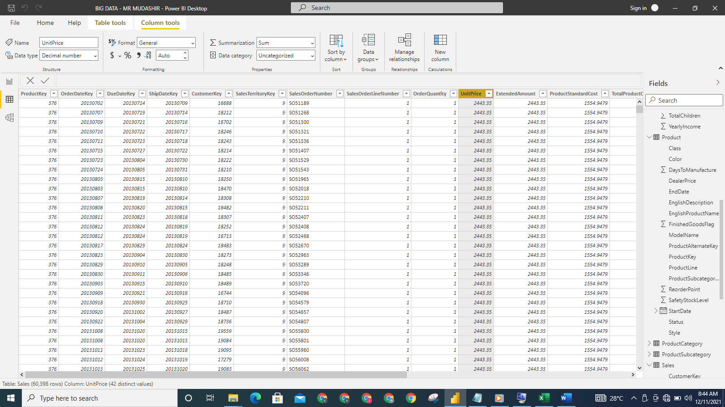

**Figure 12: The UnitPrice column before currency conversion**

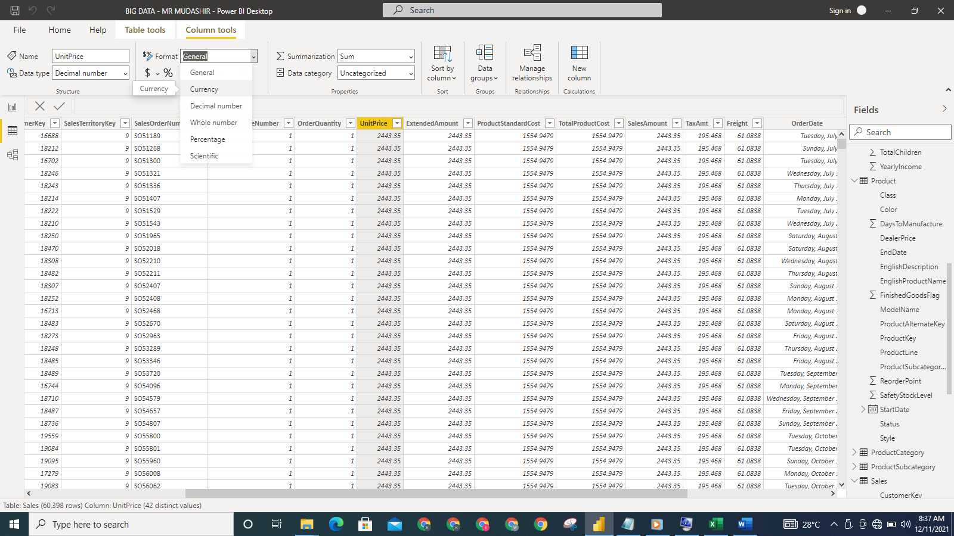

**Figure 13: The Currency Format being selected**

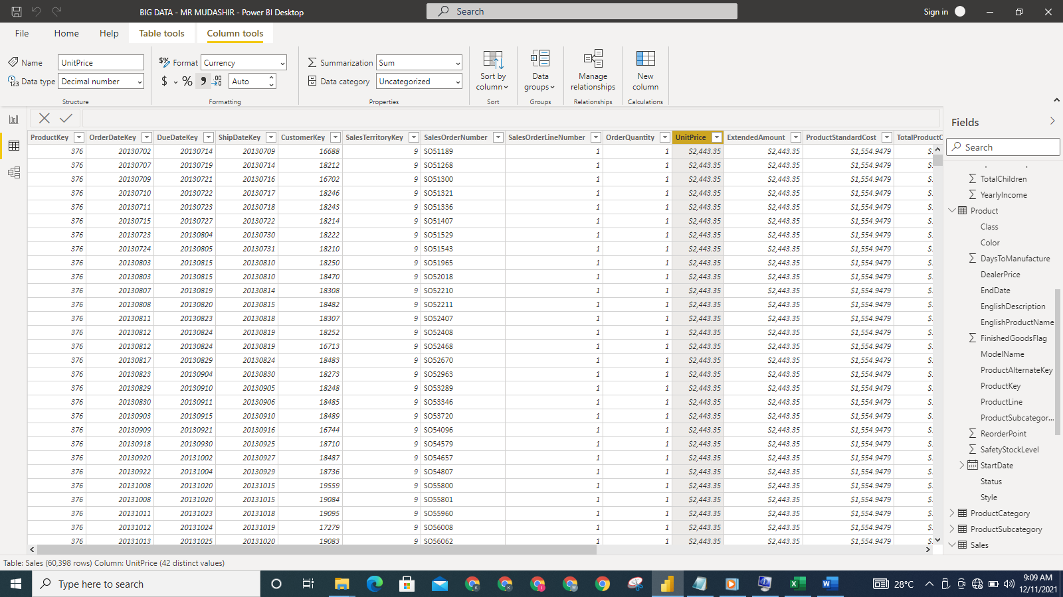

**Figure 14: The UnitPrice column after conversion**

The YearlyIncome column in the Customers table was also converted to **Currency** Format.

The values in the Gender column of the Customers table were replaced. There was initially ‘M’ representing Male and ‘F’ representing Female in the column. The values were replaced with ‘Male’ and ‘Female’ respectively. The process is shown in the screenshots below:

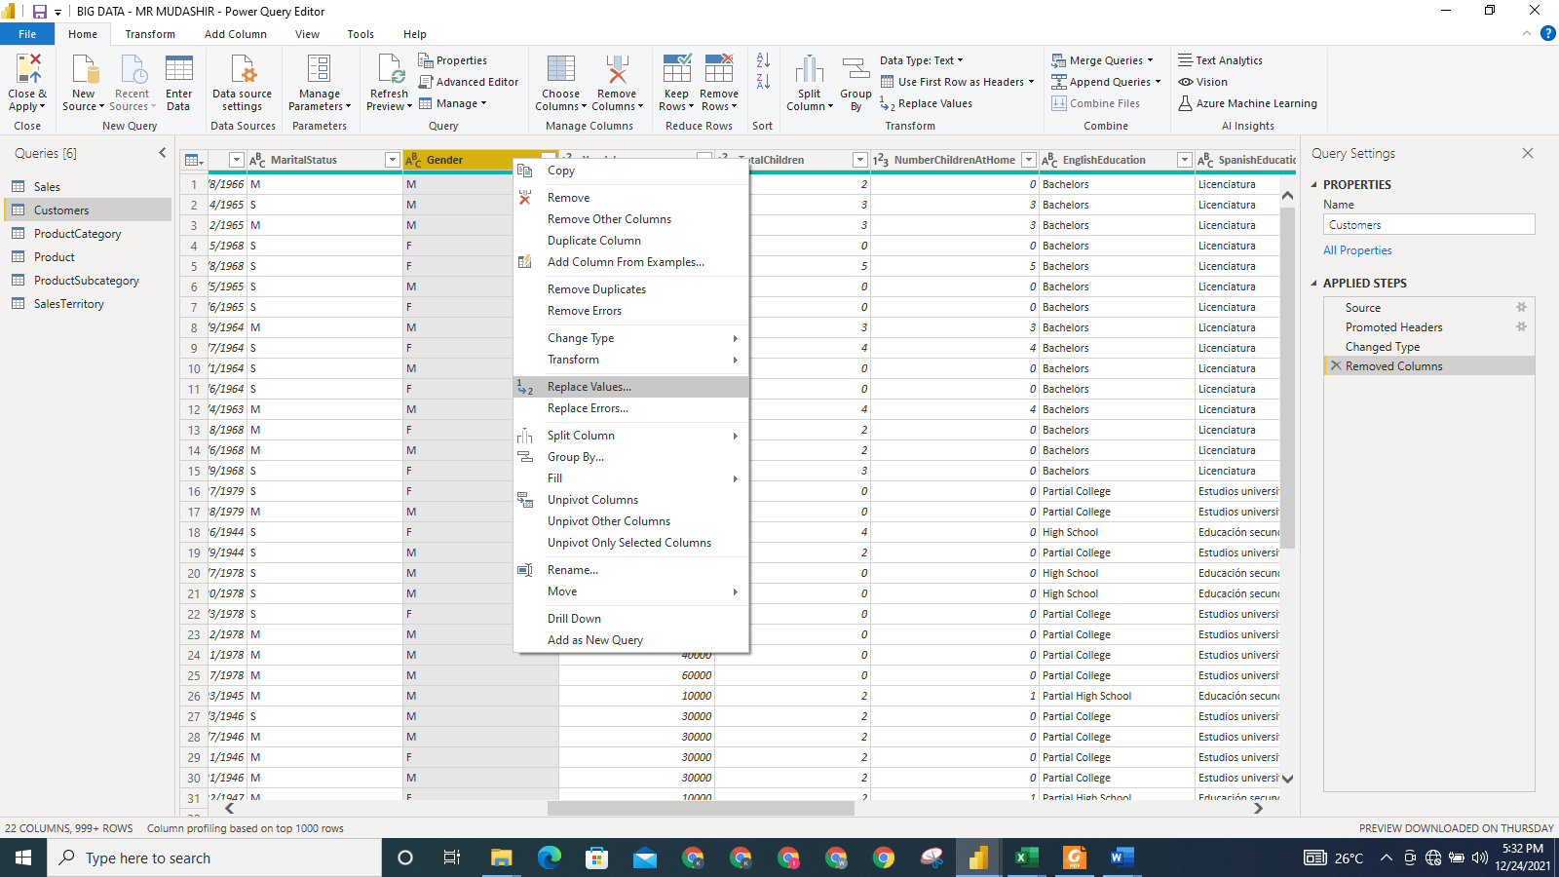

**Figure 15: Screenshot showing Replace Values being selected**

To select **Replace Values**, we right-clicked on the Gender column.

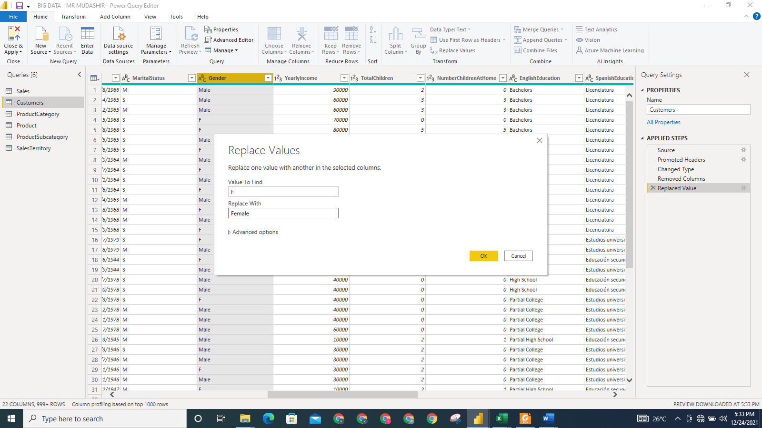

**Figure 16: Screenshot showing ‘M’ being replaced with ‘Male’ and ‘F’ being replaced with ‘Female’**

**3 BI DATA MODELLING**

The relationship among the tables in the AdventureWorks database is established after the necessary pre-processing and cleansing have been done. Having detected common columns among the tables in the data, Power BI created a relationship among the data automatically. The entity-relationship diagram of the tables in the AdventureWorks database is shown in the screenshot below.

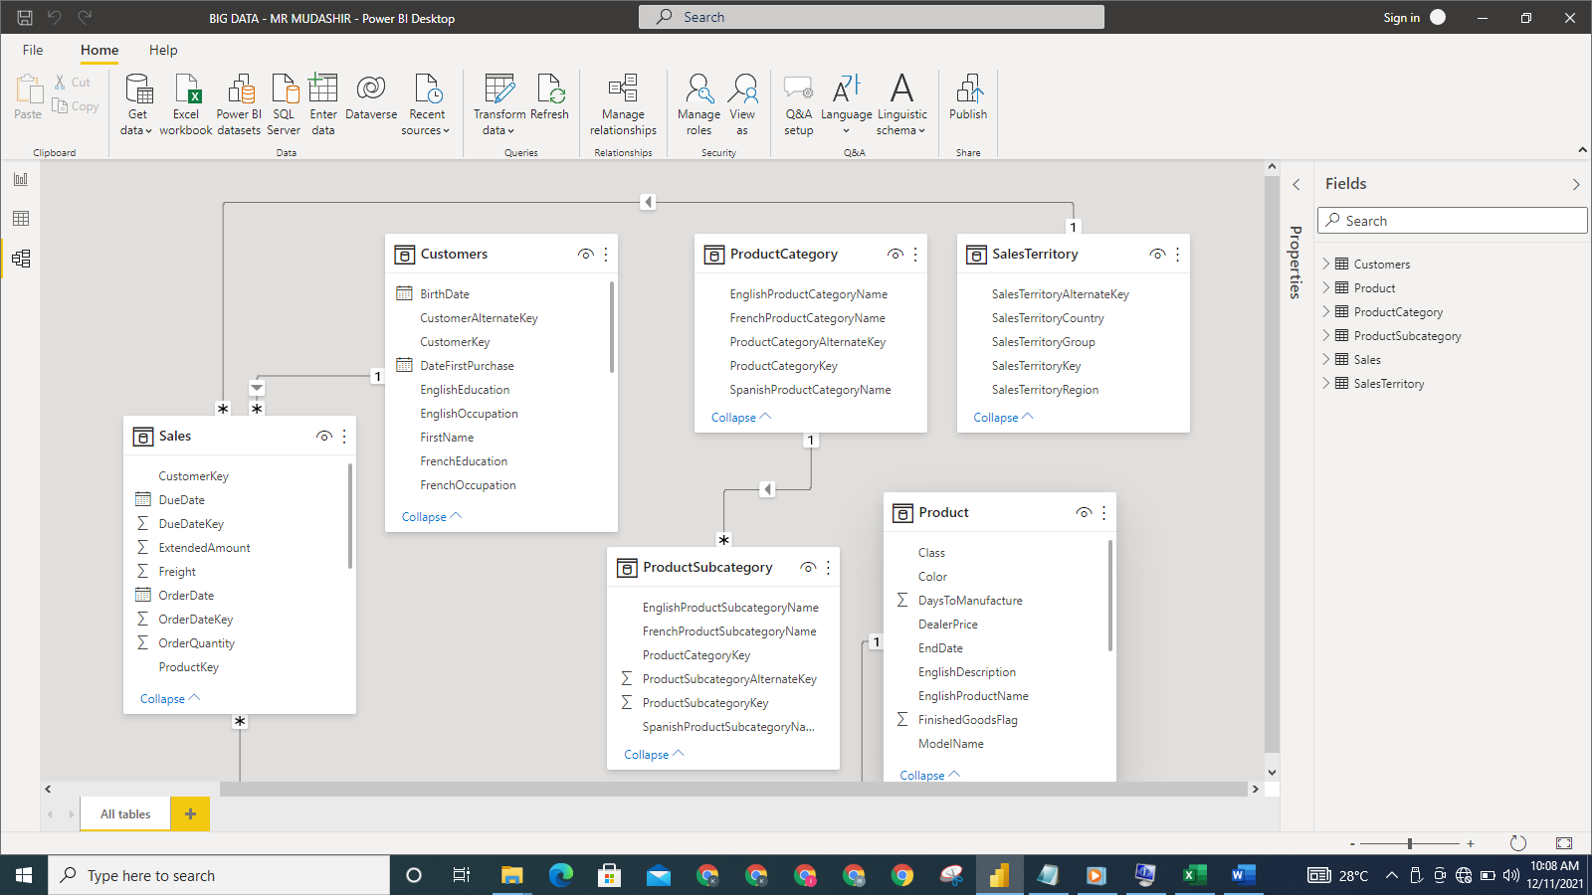

**Figure 17: Screenshot showing the automatic relationship created by Power BI**

**3.1 Creating the Calendar table**

Before doing the data modelling, the CALENDAR table is first created. This will allow us have an additional table to work with- a date table in this case. To do this, we first disabled the **Time intelligence** feature in the **Options and Settings** under **File,** then click **ok**. This is to enable us create our own custom time intelligence functions.

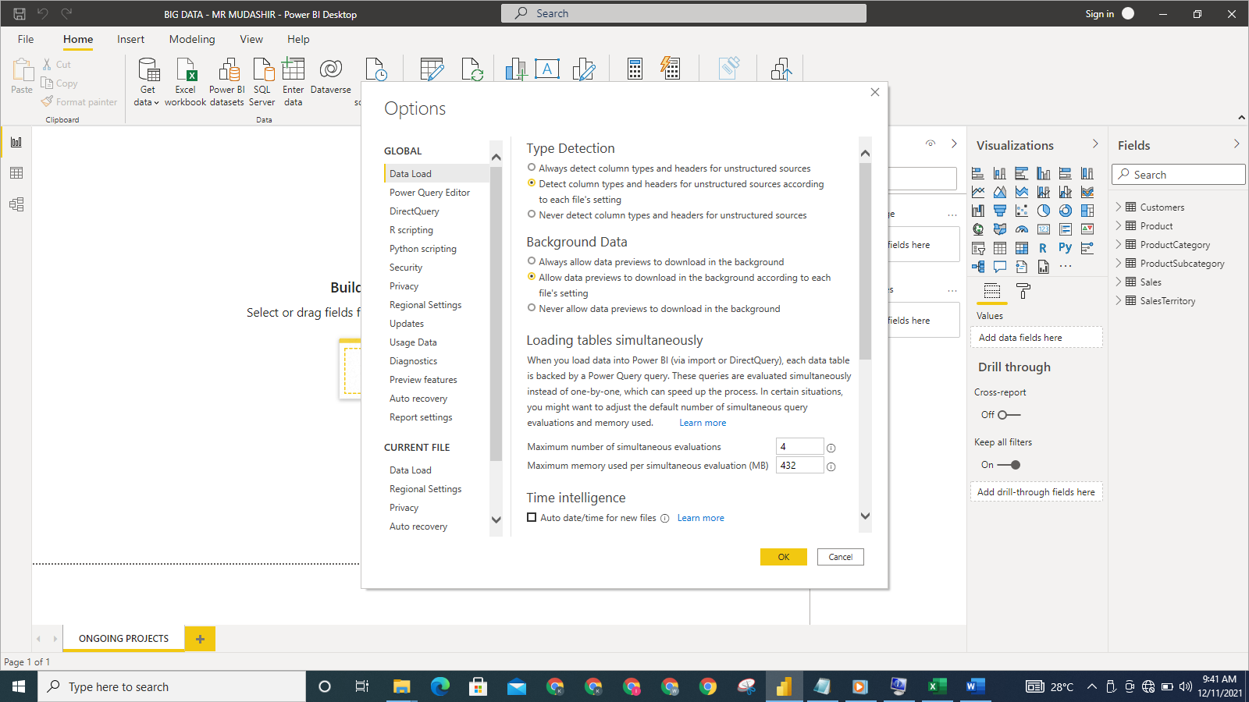

**Figure 18: Screenshot showing the Time intelligence: Auto date/time for new files being disabled**

A DAX formula, CALENDARAUTO() is used to create the CALENDAR table. We created the CALENDAR table by selecting **New table** under **Table Tools** in the **Data** view.

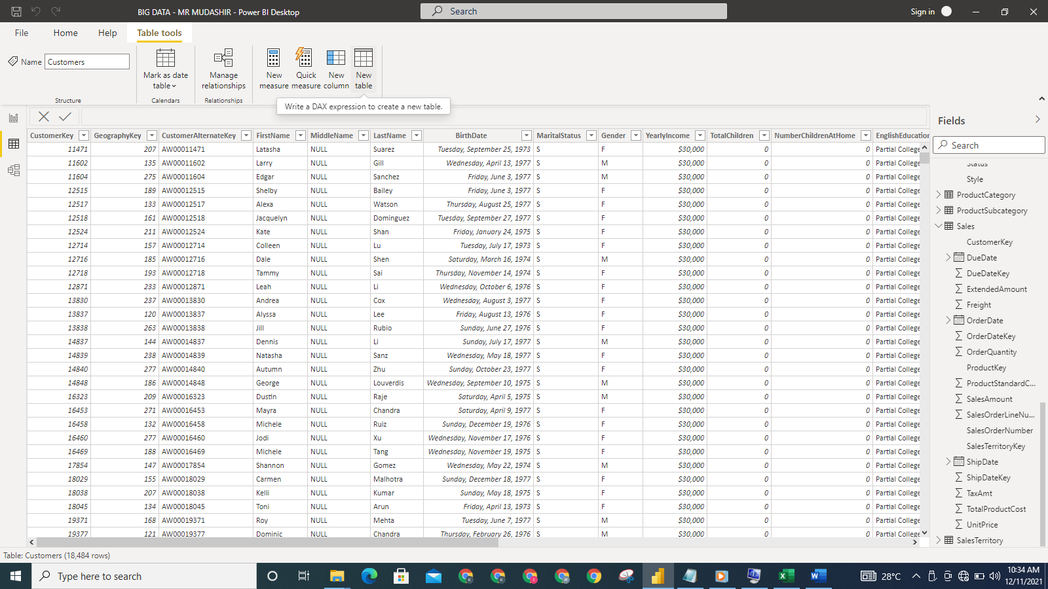

**Figure 19: Screenshot showing New table being selected**

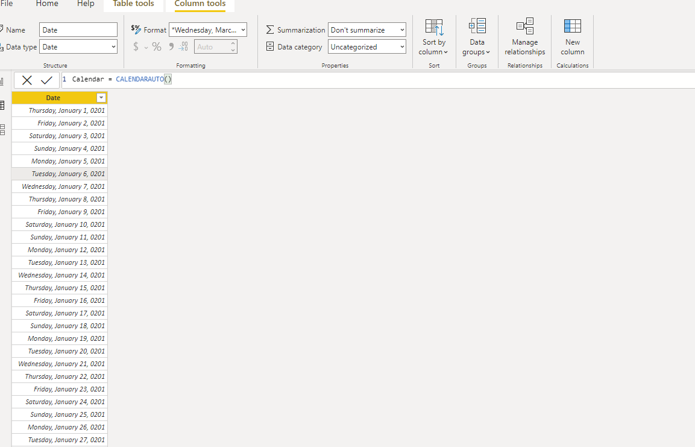

**Figure 20: Screenshot of CALENDARAUTO() DAX function**

The data type of the Date column in the Calendar is made to be of the form d mmmm yyyy. It was initially in the General Date format.

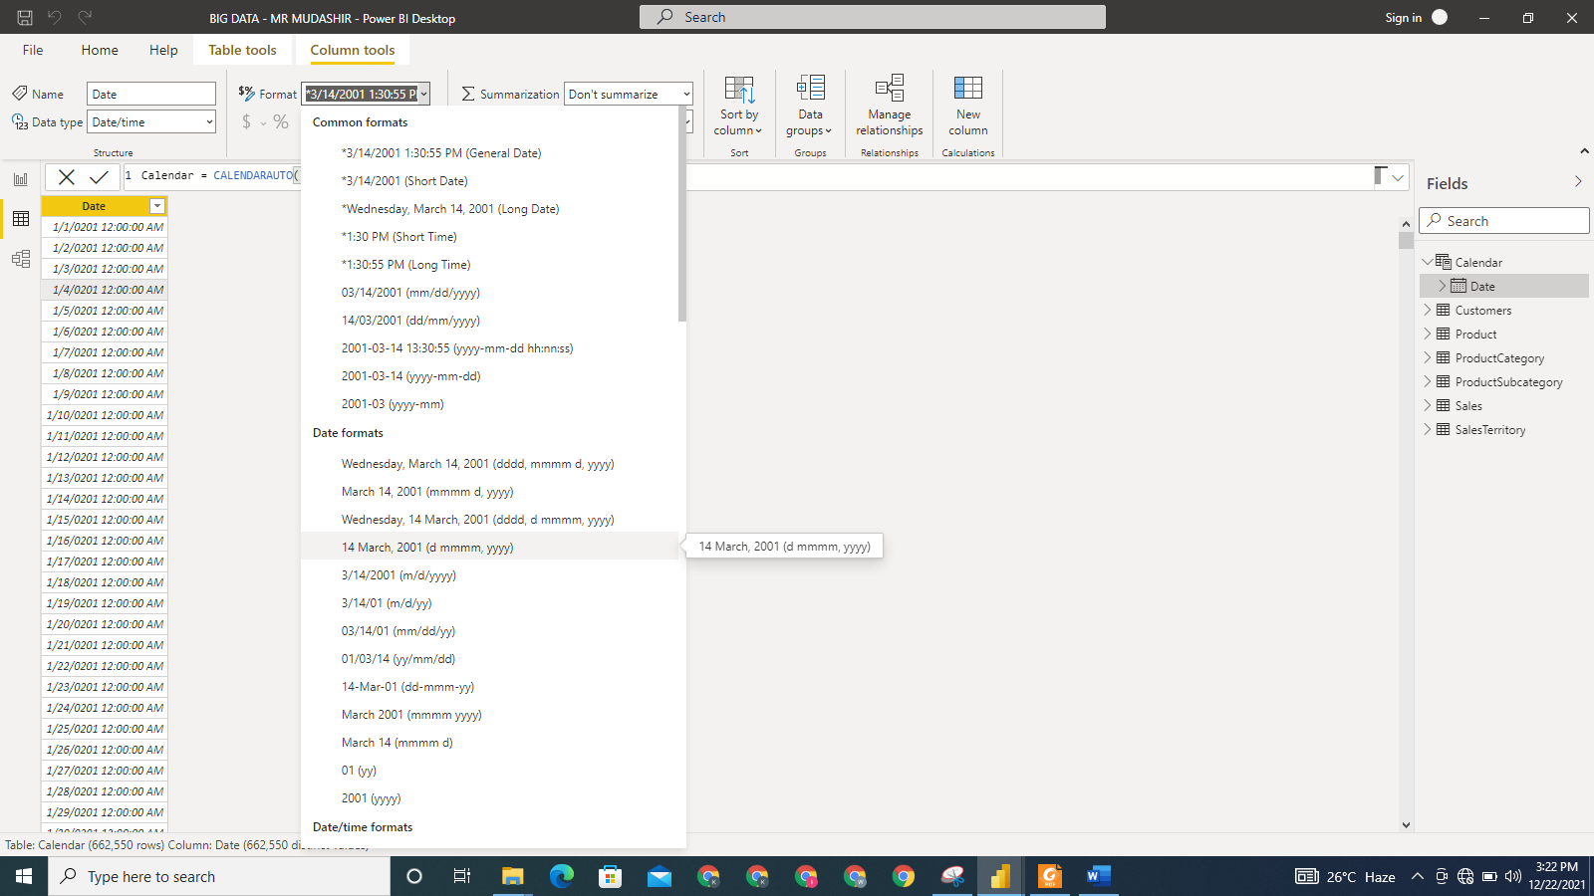

**Figure 21: Screenshot of the Date column in Calendar table converted to the form d mmmm yyyy**

The CALENDAR table is created, converted to Date data type and marked as date table. This was done by selecting **Mark as date table**, then clicking **ok**.

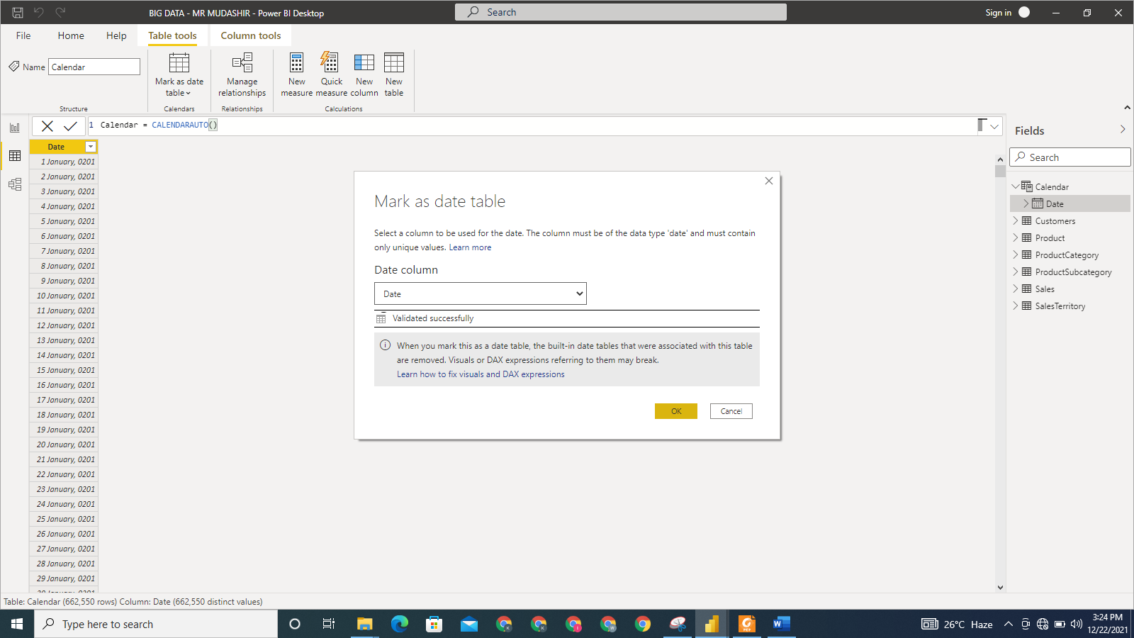

**Figure 22: Screenshot of the Calendar table created and marked as date table**

More columns are created to populate the Calendar table. To create the Year column in the Calendar table for instance, the formula used is:

Year = FORMAT(‘Calendar’[Date],”yyyy”)

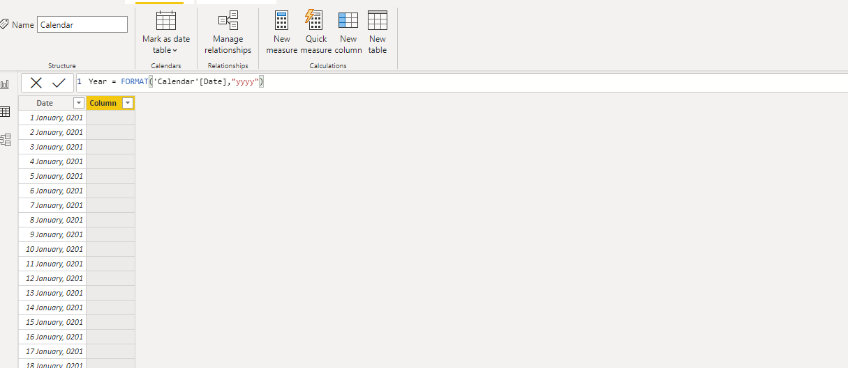

**Figure 23: Screenshot showing the Year column being added to the Calendar table**

Some more columns like Month, Day of Week, Quarter, Month Number, Year Month Number, Year Half, and Day of Week Number were added to the Calendar table using calculated column. The Calendar table is sorted using the Month Number column. This is to ensure that the table is sorted by calendar months and not alphabetically. To do this, we click on the month Number column; navigate to the **Column tools** tab, select **Sort by columns** and then select the Month Number column.

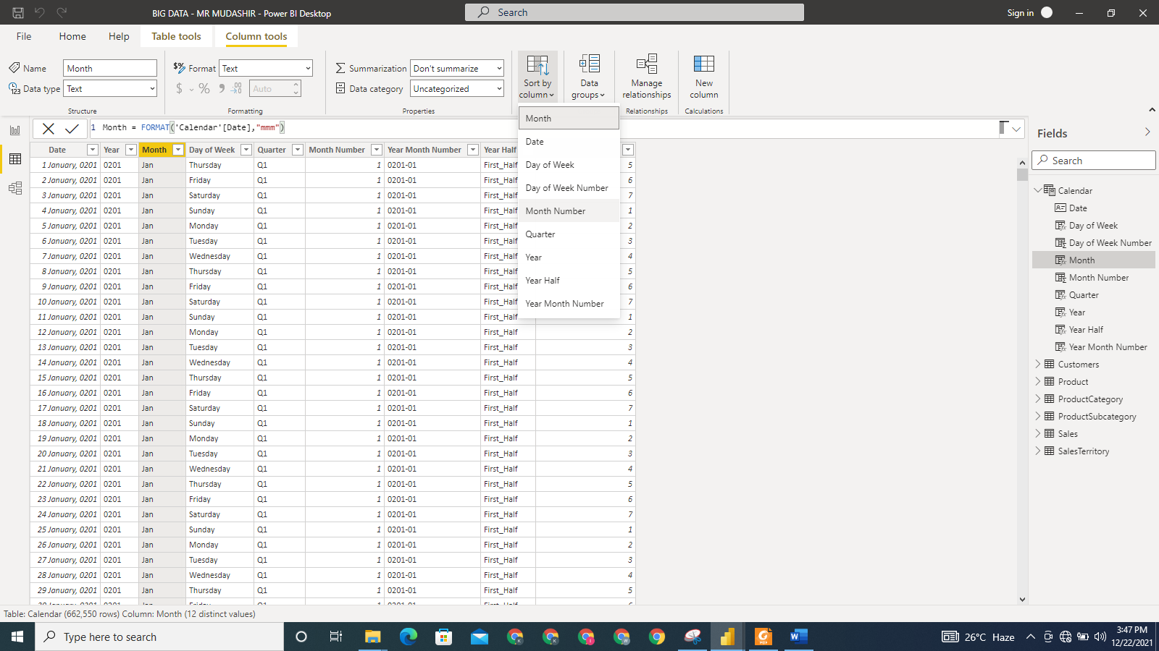

**Figure 24: Screenshot showing the Calendar table being sorted by Month Number**

There is a need to create a new relationship between the Calendar table newly created and the Sales table. To create the relationship, we click on **Manage Relationship** from the Modeling Tab in the Power BI environment. We are taken to the **Manage Relationship** dialog where we selected **New** option to create a new relationship. We are then presented with the **Create Relationship** dialog box where the relationship between Sales and Calendar tables was established. The columns used are the Date column in the Calendar table and OrderDate in the Sales table.

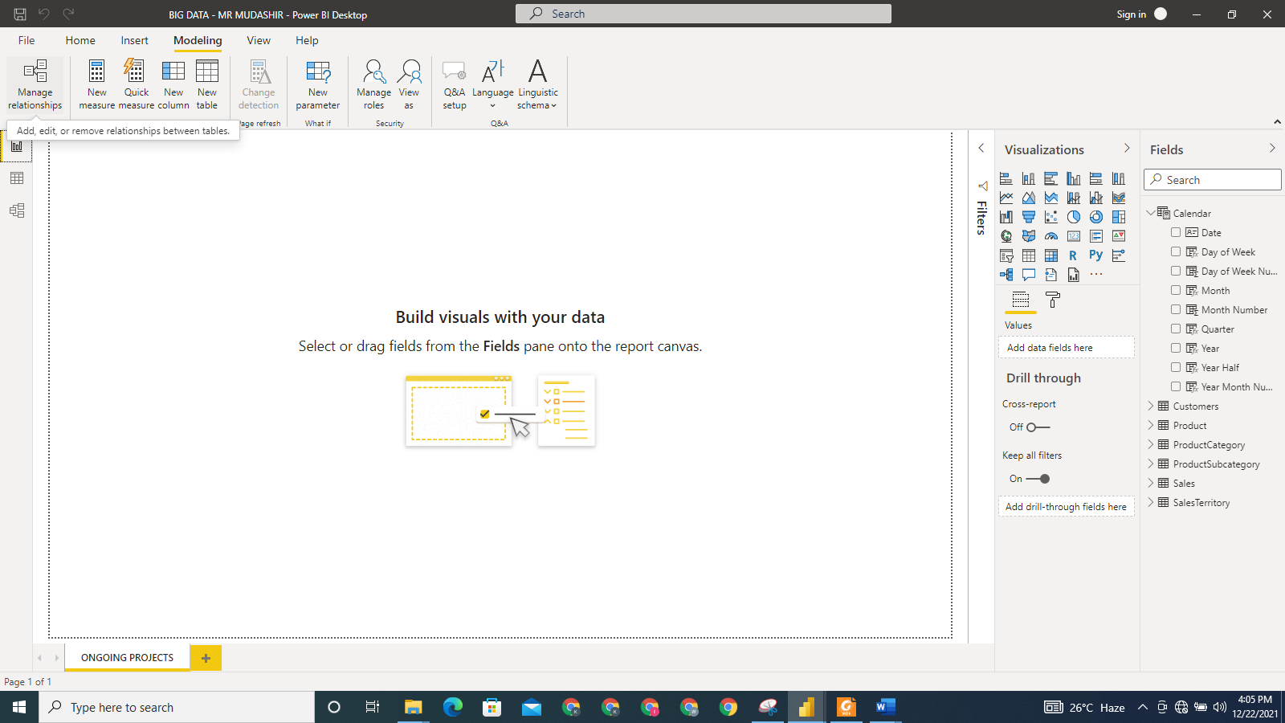

**Figure 25: Screenshot showing the Manage Relationship being selected in the Modeling tab**

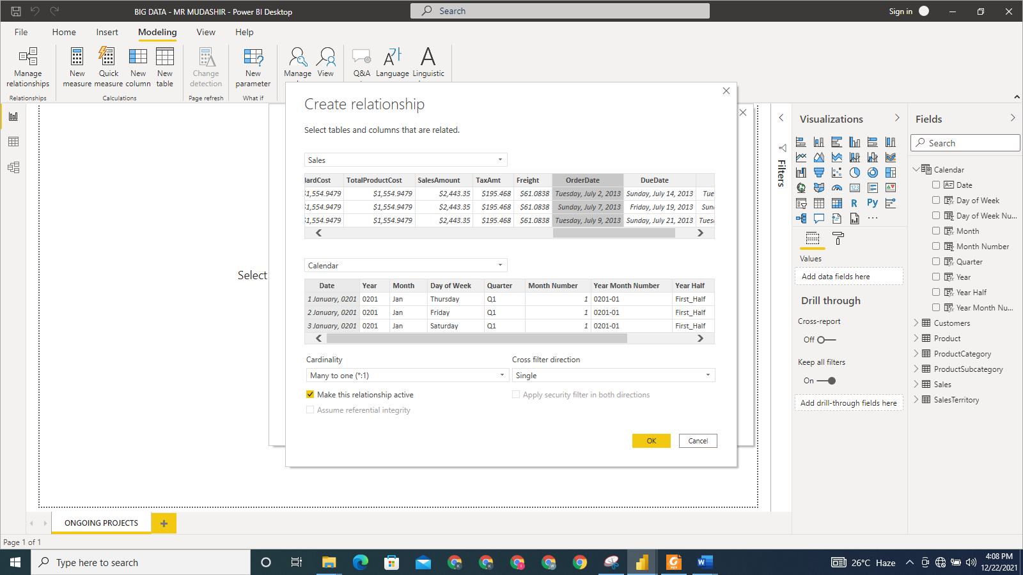

**Figure 26: Screenshot of Create Relationship dialog box**

After the relationship has been created, the data model was presented in a Star Schema as follows:

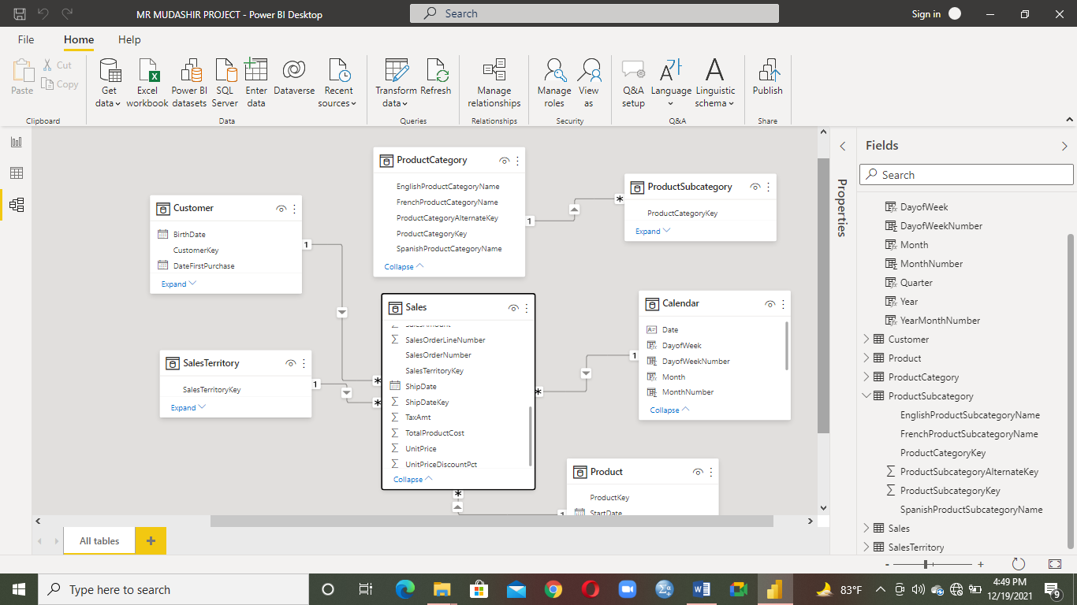

**Figure 27: Screenshot showing the data model presented using Star Schema**

**SECTION 2: Business Report**

**Adventure Works Financial Performance Analysis**

**NAME: [Please Put Name Here]**

**STUDENT ID: [Please put student ID here]**

**Executive Summary**

**Background to the Report**

Adventure Works Cycle is a multinational company dealing in bicycles and their components. This report is a detailed analysis of our business performance. It is done to enable us identify key areas needing improvements and also plan for the years ahead.

The report provides answers to the following questions:

* What is the total sales year to date?
* What is the revenue coming from each territory?
* Which gender makes most purchases?
* What is the month on month profit growth for the 2014 financial year?
* What is the year on year growth of the revenue?
* What is the average amount spent on freight?
* What category of educated people produces the most revenue?
* What is the average cost of production over the years?
* What is the minimum, maximum and average safety stock level?

The dashboard generated in this report with our data enables us communicate clearly to the stakeholders the key findings and conclusions drawn accordingly.

**Key Findings**

* The total sales year to date amounts to $9,770,899.74 in 2014. There was a 45% increase in

total sales between 2013 and 2014.

* The country generating the most revenue for the company is USA. The total revenue from USA alone was %9,389,789.51. Canada contributes the lowest amount of revenue which equals $1,977,844.86. Some other countries contributing to the revenue include Australia, United Kingdom, and Germany.
* The region where the company is generating the highest revenue is Australia. The company garnered $9.06M in the region. This represents 30.86% of the whole amount of revenue generated. Southwest, Northwest, Southeast, Northeast and Central are all under USA however. This means there are 5 regions of sales in the USA alone.
* Within the period covered, the company generated more revenue from the female gender than from the male gender. The revenue made from female was $14, 813, 618.68. The revenue generated from the male gender on the other hand was $14, 545, 058.55. There is a close margin however between the revenue generated among the female gender and the male gender.
* The monthly profit growth of the company was not stable. As a matter of fact, the growth rate declines in the middle of 2014 and continues to decline. The value of the monthly profit growth rate was -5.62 in August 2014.

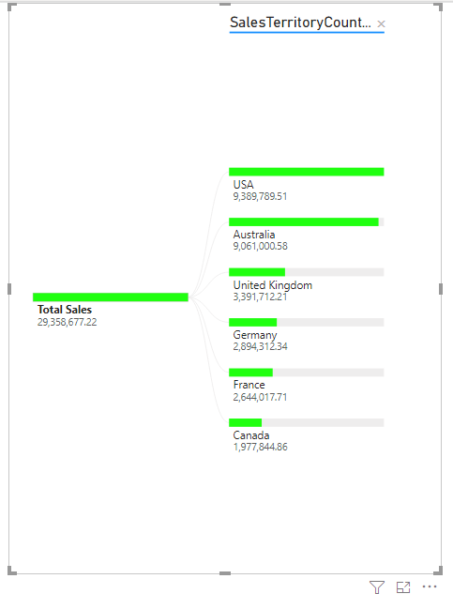

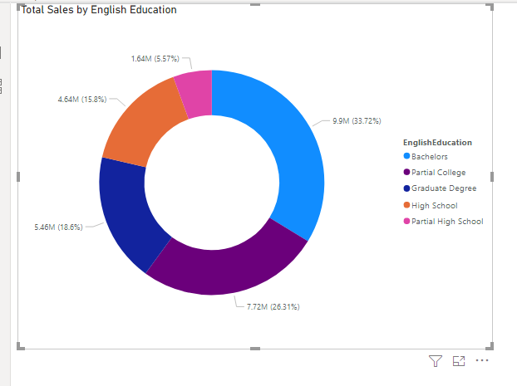

**Recommendations**

* The company should come up with different fascinating packages that will appeal to different demography of customers and should be well publicised on its website, since it is evident that both genders patronise the company.
* The company should focus on the countries where it is making most revenue and ensure more people more people continues to patronise in those countries.
* There should be cost reduction strategy that will ensure the monthly profit growth of the company will increases.
* The company should focus more on the highly educated category of its customers since it is evident that there is a relationship between the level of education and the amount generated as revenue.
* The company should aim for converting visitors to its website to a potential customers by offering irresistible offers that will get them fascinated to its products. This can be done by offering discount to customers who buy in bulk; promotion strategy and reward on referral.

**INTRODUCTION**

The analyses in this report are based on the AdventureWorks dataset made available on Kaggle. Below is the link to the dataset: <https://www.kaggle.com/ukveteran/adventureworks>

The report is a detailed analysis of the financial performance of AdventureWorks for the periods the company has been in business. The relationship among the tables in the dataset was established using the Star Schema, with a single fact table and the other tables being the dimension tables. The Star Schema used to model the data is presented in the screenshot below:



**Figure 1: Data model using the Star Schema**

7 tables are used for the data model and they are Sales, Product, Customer, Calendar, SalesTerritory, productCategory and ProductSubcategory. Sales table is the fact table, while the remaining contains the dimensions used for the analyses. The columns in all of these tables enable us to provide answers to key business questions. The data have been pre-processed to ensure that they are fit enough for our analyses.

We will employ charts, tables, measures and calculated columns to provide answers to the various questions outlined above. The questions are addressed in our analysis as follows:

**2.1 What is the total sales year to date?**

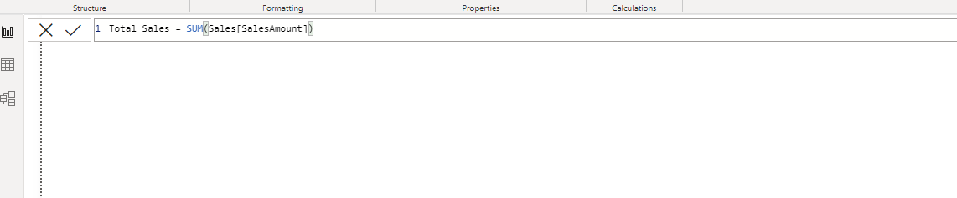

**Figure 2: Total Sales Measure**

To find the total sales year to date, we first create a measure: Total Sales. The measure will be useful in calculating the total sales year to date of the company.

* To create this measure, the SUM function was used. We selected **New Measure** while clicking on the Sales table. The name of the measure so created is Total Sales.



**Figure 3: Measure for Total Sales Year to Date**

The formula in the screenshot above was used to find the total sales year to date. It utilizes the TOTALYTD function, the Total Sales measure created earlier and the Date column in the Calendar table.

* Having created the Total Sales measure, we then created the Total Sales YTD using the function: TOTALYTD([Total Sales], ‘Calendar’[Date]) after selecting **New Measure** in the same table.

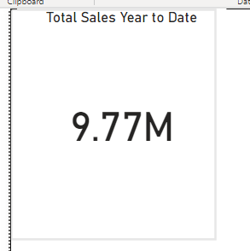

**Figure 4: The Card visual is used to present the total sales year to date.**

Total sales year to date is a scalar value, this makes it possible for us to present it using the Card visual.

* To see the amount of Total Sales YTD, we placed the value on a card visual which presents it as a scalar value. We created the visual by clicking on the Card visual and then dragging the Total Sales YTD measure to **Fields** box.

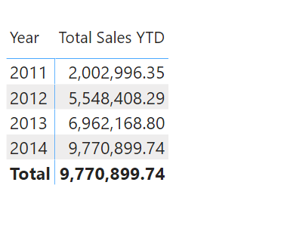

**Figure 5: Matrix visual showing total sales year to date for each year**

To see how the total sales year to date has accumulated over the years, we employed the Matrix visual to present the data.

* We created this visual by clicking on the Matrix visual and the dragging Year column in the Calendar table to the **Rows** box and Total Sales YTD to **Values** box.

It was observed that the total sales year to date has increased substantially over the years. It totalled $9,770, 899.74 in 2014.

**2.2 What is the revenue coming from each territory?**



**Figure 6: Decomposition Tree showing the Total revenue by sales territory country**

With the Decomposition Tree visual, we are able to see at a glance the amount of sales revenue coming from each territory country. The total revenue amount is $29,358,677.22. It was clear from the visual that most of our sales revenue is coming from USA- a sum of $9,389,789.51. Canada contributes the least to our sales revenue- a sum of $1,977,844.86.

* This visual was created by clicking on the Decomposition Tree visual, and dragging Total Sales measure to **Analyze** box and SalesTerritoryCountry from the SalesTerritory table to **Explain by** box. The color was changed from the default blue color to a shade of green in the **Format** section of the **Visualizations** pane. The color code of the shade of green is **#20FF10**.

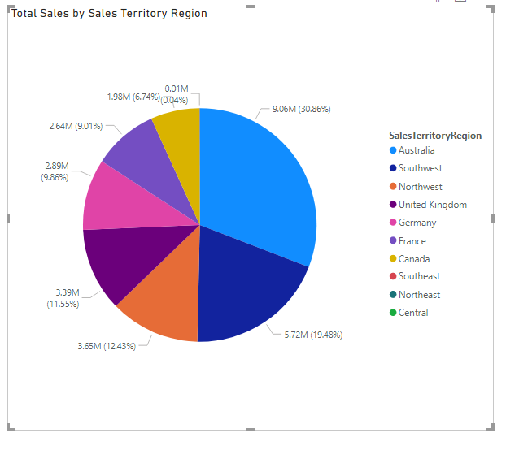

**Figure 7: Pie chart of sales revenue by sales territory region**

Going by the sales territory region, it is shown on the pie chart that Australia contributes the most to sales revenue. It is important to note however that the total coming from USA in the Decomposition Tree in figure 6 are contributed by Southwest, Northwest, Southeast, Northeast and Central combined. The pie chart allows us to present the sales revenue by sales territory region, so it is clear which territory region contributes the most and which territory region contributes the least to the total sales revenue. It is evident that Canada contributes the least to the sales revenue.

* To create the Pie chart visual, we select the Pie chart from the list of visuals available. Total Sales is dragged to the **Values** box and SalesTerritoryRegion column from the SalesTerritory table is dragged to **Legend** box.

**2.3 Which gender makes most purchases?**

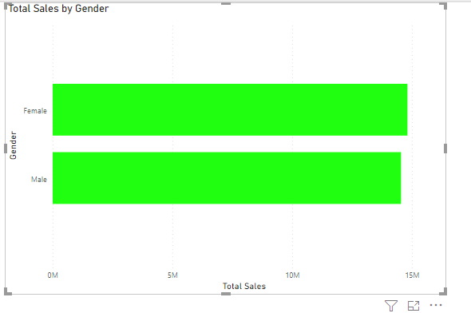

**Figure 8: Bar chart showing total sales by gender**

The bar chart is used to display the purchases made by both genders. It was seen from the bar chart that female make a little more purchase than male. The sales made to the female gender is worth $14,813,618.68, while the sales made to the male gender is worth $14, 545, 058.55. This shows that male customers patronise us as much as the female customers patronise us, but within the periods covered, female customers made more purchases than their male counterpart.

* To create the bar chart, we made use of Stacked bar chart visual. Gender was dragged from the Customers table to the **Axis** box and Total Sales measure was dragged to the **Values** box. The color was changed from the default blue color to a shade of green in the Format section of the Visualizations pane. The color code of the shade of green is **#20FF10**.

**2.4 What is the month on month profit growth for the 2014 financial year?**

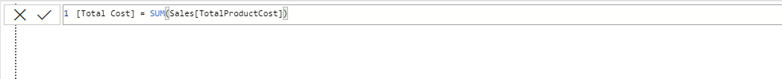

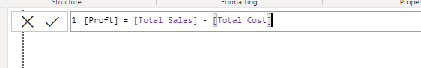







**Figure 9: DAX measures used to calculate the month on month profit growth**

* We first created a measure to calculate the total cost.
* We created a measure to calculate the profit using the function shown in screenshot in figure 9.
* We then use a measure to calculate the previous month profit. The PREVIOUSMONTH function was employed as a filter to get the previous month profit.
* We were able to find the variance in the profit by finding the difference between the current month and the previous month profit.
* With these, we were able to find the monthly profit growth for 2014 financial year.

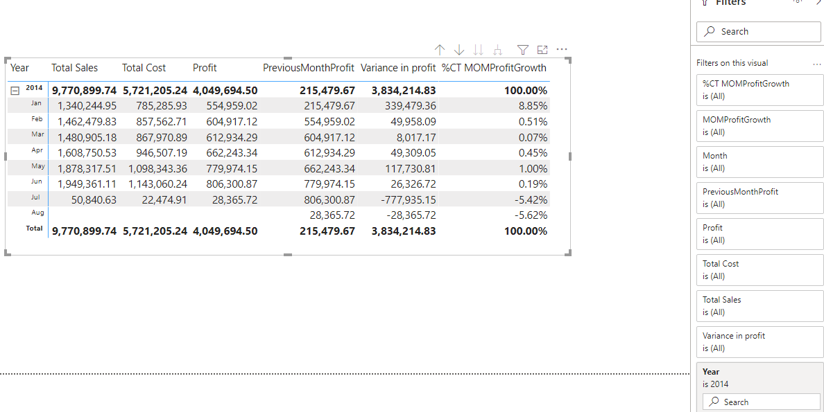

**Figure 10: Matrix visual showing month on month profit growth for the year 2014.**

It was found from the visual that there has been a fall and rise in the monthly growth of profits made in 2014. The growth rate reduced drastically in the middle of 2014 and continued to decline thenceforth. It has declined to -5.62% as at August 2014.

* The Matrix visual is used to show the monthly growth rate of profit. We clicked on Matrix visual to bring it to the canvas, and then drag the following measures to the **Values** pane: Total Sales, Total Cost, Profit, PreviousMonthProfit, MOMProfitGrowth. The Calculated columns in the Calendar table: Year and Month were dragged to the **Rows** box. To convert the month on month profit growth to percent, we clicked on the drop down on MOMProfitGrowth in the **Value** box and selected **Show value as Percent of column total.**
* To focus on 2014, we use the **Year** section in the **Filters** **pane.** With the filter, we were able to pick only the year 2014.

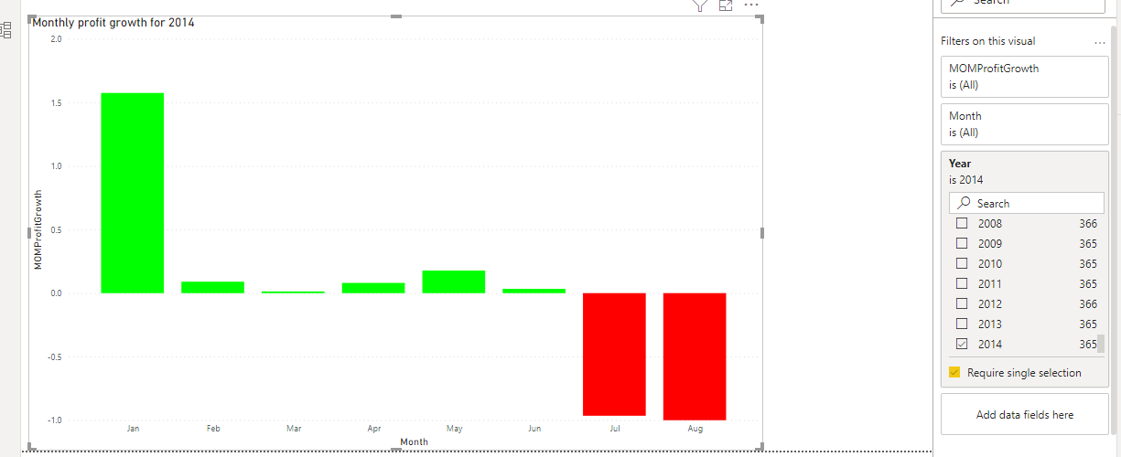

**Figure 11: Stacked column chart of monthly profit growth**

To see clearly the pattern of growth in the monthly profit in 2014, a bar chart was used to present the month on month growth calculated. It can be seen clearly that the profit has declined over the months in 2014.

* To create the visual, we click on the Stacked column chart visual, drag MOMProfitGrowth to **Values** box and Month column from the Calendar table to **Axis** box.
* The color of the positive bars was changed from the default color to green color and that of the negative bars were changed to red color. We did this by clicking on the **Format** section under the **Visualizations** pane. We then click on **Data colors**, flipped on **Show all** just below **Default color**. This enabled us see all the colors for each month. We changed the color to green for Jan, Feb, Mar, Apr, May and Jun as they are having positive bars. Also, we changed the color to red for Jul and Aug as they are having Negative bars.
* To focus on 2014, we use the **Year** section in the **Filters** **pane.** With the filter, we were able to pick only the year 2014.

**2.5 What is the year on year growth of the revenue?**

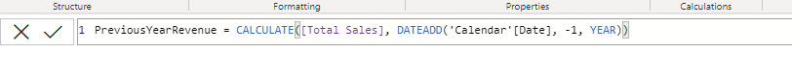





**Figure 12: Measures used to calculate the year on year revenue growth**

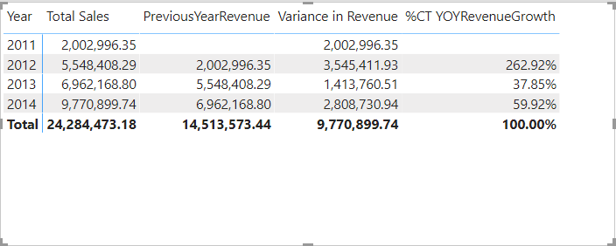

**Figure 13: Matrix showing year on year growth of revenue**

We used Matrix visual to present the year on year revenue growth and other measures used in arriving at the calculation. It was found that there is an increase in the yearly revenue of our company.

* To create the visual, we clicked on the Matrix visual, then drag Year column in the Calendar table to **Axis** box and Total Sales, PreviousYearRevenue, Variance in Revenue, YOYRevenueGrowth to **Values** column. To convert the year on year revenue growth to percent, we clicked on the drop down on YOYRevenueGrowth in the **Value** box and selected **Show value as Percent of column total.**

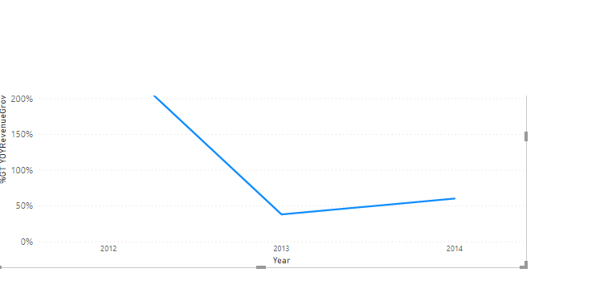

**Figure 14: Line Chart of year on year revenue growth**

The line chart allows us to see the trend in revenue growth over the years. There was a decrease in the annual revenue growth but it began to rise after 2013.

* To create the line chart, we selected Line chart visual, we dragged year column in the Calendar table to **Axis** box and YOYRevenueGrowth to **Values** box.

**2.6 What is the average amount spent on freight?**

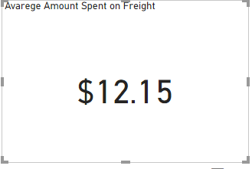

**Figure 15: Average amount spent on freight**

The Card visual is used to show the average amount that was spent on freight. It was found that on average, the company has spent $12.15 as freight.

* To create the visual, we selected Card from the list of visuals. We dragged Freight to the **Fields** box. We got the average by clicking on the drop-down arrow just beside Freight and selected **Average** as our aggregation type.

**2.7 What category of educated people produces the most revenue?**



**Figure 16: Donut chart of Total revenue by category of customers education**

With the Donut chart, we are able to ascertain the total revenue from respective categories of the education of our customers. It was found that the largest portion of revenue is from our customers have Bachelor’s degree. The total revenue made from them was $9.9M. We generated the least amount of revenue from customers who attended partial high school. The revenue made from them was $1.64M.

* To create the Donut chart, we placed it on the canvas by selecting it. We dragged **Total Sales** measure to value and EnglishEduaction in the Customers table to **Legend** box.

**2.8 What is the average cost of production over the years?**

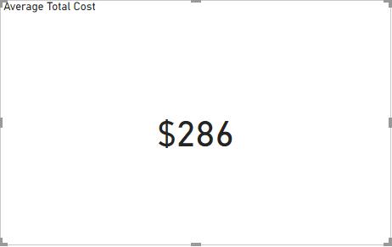

**Figure 16: Average cost of production**

The card visual enabled us to present the average total cost. The average total cost was found to be $286.

* To create the visual, we selected Card from the list of visuals. We dragged TotalProductCost in the sales table to the **Fields** box. We got the average by clicking on the drop-down arrow just beside TotalProductCost and selected **Average** as our aggregation type.

2.9 What is the minimum, maximum and average stock level?

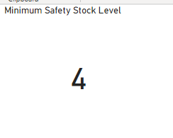

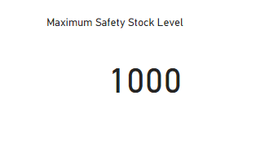

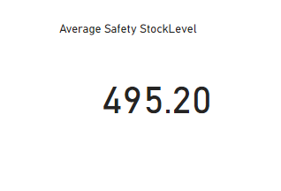

**Figure 17: Minimum. Maximum and average safety stock level**

From Figure 17, it was found that the minimum safety stock level is 4, maximum stock level is 1000 and the average safety stock level is 495.20.

* To create the visual for minimum safety stock level, we selected Card from the list of visuals. We dragged SafetyStockLevel in the Product table to the **Fields** box. We got the minimum by clicking on the drop-down arrow just beside TotalProductCost and selecting **Minimum** as the aggregation type.
* To create the visual for maximum safety stock level, we selected Card from the list of visuals. We dragged SafetyStockLevel in the Product table to the **Fields** box. We got the maximum by clicking on the drop-down arrow just beside TotalProductCost and selecting **Maximum** as the aggregation type.
* To create the visual for maximum safety stock level, we selected Card from the list of visuals. We dragged SafetyStockLevel in the Product table to the **Fields** box. We got the average by clicking on the drop-down arrow just beside TotalProductCost and selecting **Average** as the aggregation type.

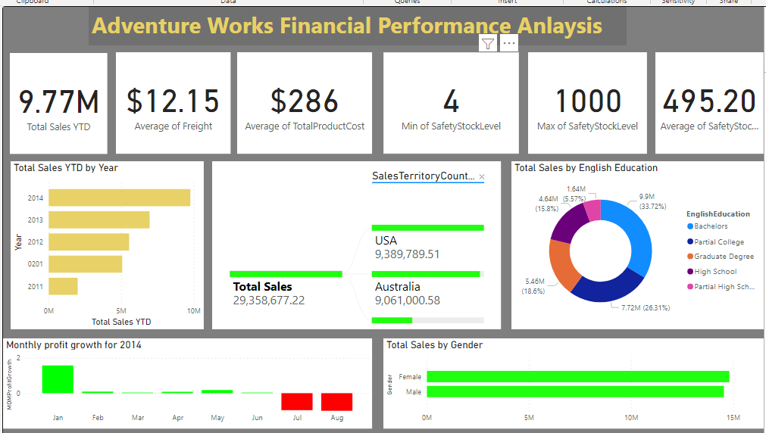

**Figure 18: Dashboard of Adventure Works financial performance analysis**

**Conclusion**

Microsoft Power BI makes it possible to build reports which allow us provide answers to key business questions. In this report, we made some findings and they include the following:

* The total sales year to date amounts to $9,770,899.74 in 2014. There was a 45% increase in total sales between 2013 and 2014.
* The country generating the most revenue for the company is USA. The total revenue from USA alone was %9,389,789.51. Canada contributes the lowest amount of revenue which equals $1,977,844.86. Some other countries contributing to the revenue include Australia, United Kingdom, and Germany.
* The region where the company is generating the highest revenue is Australia. The company garnered $9.06M in the region. This represents 30.86% of the whole amount of revenue generated. Southwest, Northwest, Southeast, Northeast and Central are all under USA however. This means there are 5 regions of sales in the USA alone.
* Within the period covered, the company generated more revenue from the female gender than from the male gender. The revenue made from female was $14, 813, 618.68. The revenue generated from the male gender on the other hand was $14, 545, 058.55. There is a close margin however between the revenue generated among the female gender and the male gender.
* The monthly profit growth of the company was not stable. As a matter of fact, the growth rate declines in the middle of 2014 and continues to decline. The value of the monthly profit growth rate was -5.62 in August 2014.
* The year on year revenue growth was 37.85% in 2013 and it was 59.92% in 2014.
* The average amount spent on freight was $12.15.
* The highest revenue was generated from our customers who are bachelor’s degree holders. Meanwhile, the least revenue was $1.64 million, generated from those hold partial high school degree.
* The cost of production averages $286 over the years.
* The minimum safety stock level was 4; the maximum safety stock level was 1000 and the safety stock level averages 495.20.

On the basis of the findings made above, the following recommendations were made:

* The company should come up with different fascinating packages that will appeal to different demography of customers and should be well publicised on its website, since it is evident that both genders patronise the company.
* The company should focus on the countries where it is making most revenue and ensure more people continue to patronise in those countries.
* There should be cost reduction strategy that will ensure the monthly profit growth of the company will increases.
* The company should focus more on the highly educated category of its customers since it is evident that there is a relationship between the level of education and the amount generated as revenue.
* The company should aim for converting visitors to its website to potential customers by offering irresistible offers that will get them fascinated to its products. This can be done by offering discount to customers who buy in bulk; promotion strategy and reward on referral.
* The company should increase its safety stock level so as always meet up with their customers’ demand.